Brian McGregor Bio

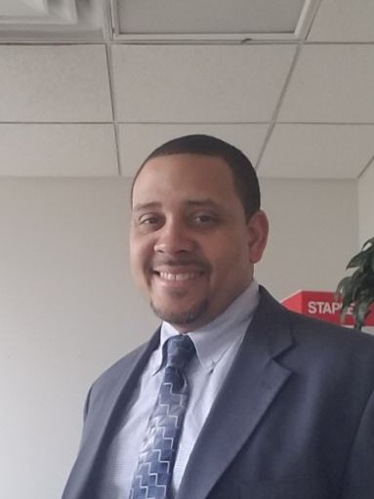
Dr. Brian McGregor is a community psychologist by training and specializes in the areas of behavioral health equity and criminal justice. He is the founder and owner of McGregor Research & Consulting, LLC which offers consultation and evaluation services, with a focus on educational, health, and criminal justice initiatives. Dr. McGregor is also an Adjunct Clinical Assistant Professor in the Department of Psychiatry & Behavioral Sciences at the Morehouse School of Medicine. He earned his bachelor’s degree in Psychology from Morehouse College and completed his master’s and doctorate degrees in Clinical/Community Psychology from the University of South Carolina, one of few programs of its kind at the time. While in graduate school, he received a pre-doctoral Mental Health and Substance Abuse Fellowship from the American Psychological Association, funded by the Substance Abuse & Mental Health Services Administration (SAMHSA). After completing his doctoral studies, he provided individual and group psychotherapy, crisis services and reentry planning in medium and maximum security prisons in the state of Alabama from 2006 to 2008. During those 2.5 years, he served as both a clinician and supervisor of mental health services. He then returned to the Atlanta University Center to complete a Health Policy & Leadership Fellowship at the Satcher Health Leadership Institute (SHLI) at the Morehouse School of Medicine. As a member of the 2009 – 2010 inaugural class, Dr. McGregor focused his postdoctoral training on mental and behavioral health policy, viewed through a health equity lens. After the fellowship, he worked in SHLI as a behavioral health disparities researcher within the Division of Health Policy and in the Kennedy Satcher Center for Mental Health Equity, conducting community based research and program evaluation involving underserved communities. Dr. McGregor provides his expertise to several organizational boards, including Foreverfamily, a non-profit organization serving children and families in Georgia with incarcerated parents and the Academic Consortium of Criminal Justice Health, where he serves as Treasurer.

